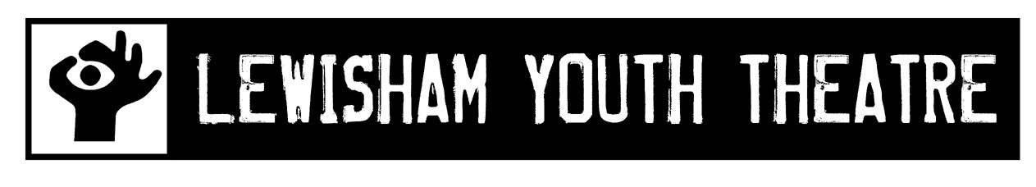

Job Description

Role: Photography Facilitator

Co-Facilitator: Step-Up Coordinator, with specialism in drama

Project: Bellingham Youth Club Project

Responsible to: Artistic Director & Company Manager

Responsible for: Workshop Assistants (jointly with Co-Facilitator)

Project Dates: 11 x sessions 10th May – 26th July, Thursday evenings (tbc)
2 x intensive days during week of 23rd July

Showcase: Thursday 26th July

Fee: £1,020 (inclusive of planning & evaluation)

Lewisham Youth Theatre Background
LYT has created theatre with and for young people aged from 3 to 21in Lewisham since 1987. We have been resident at the Broadway Theatre in Catford since 2000. All our Youth Theatre projects perform full scale productions in the studio theatre at the Broadway and in other venues around the borough. Our youth theatre projects are free to members. We do not audition members but we ask for and expect commitment to the project. 50% of our members are referred to us through schools. We aim to give our members as near to professional experience as possible. We have high production values and we expect commitment and passion from all who work with us. All our projects work from text. A high percentage of our members go on to work within the profession.

Bellingham Youth Project Overview
The project will work with up to 20 young people aged 12-17 at the Bellingham Gateway Youth Club using a mixture of drama and photography to help increase the confidence and key social skills of the group. The young people will also interact with the Bellingham Golden Oldies (Senior Citizens) group. The exact interaction and how this influences the project will be planned between the Photo/Drama Facilitator and the Step-Up Coordinator. The young people will work towards creating a visual presentation that will be showcased at the Broadway Theatre during LYT’s Junior Youth Theatre performance on 26th July 2012.

Photography Facilitator Role Overview
The Photography Facilitator will work closely with the Step-Up Coordinator to plan and deliver the project, using the photographic medium to engage and inspire young people’s creativity and self-expression. The Facilitator will use their photographic skills and knowledge to lead exercises and activities that engage participants in an understanding of creating, interpreting and photographing images. The Facilitator will bring an understanding of framing, light and colour to the sessions that will help the group gain a greater sense of creating meaning through images. The Facilitator will have experience of running workshops in photography and interest in working creatively with young people aged 12 – 17.

Photography Facilitator Responsibilities

The Facilitator, along with the Step-Up Coordinator, has overall responsibility for delivering fun and creative activities that fulfil the goals of the project and ensuring that young people engage positively in these activities. Specific responsibilities include:

- Delivering 11 weekly sessions and 2 intensive day sessions in order to fulfil the goals of the project.

- Plan sessions and overall programme with the Step-Up Coordinator.

- Create a written plan for each session.

- Arrive 15 minutes prior to each session in order to ensure the space is set up and safe to use.

- Help to coordinate the final visual presentation for the showcase.

- Evaluate each session using LYT’s standard session evaluation tools.

- Safeguard the young people in the sessions and during any travel for the project, following LYT’s Safeguarding Policy at all times.

- Hold a valid Criminal Records Bureau Enhanced Disclosure, taken no more than 2 years prior to commencement of the project.

Person Specification

Essential
- Knowledge and Experience of photography theory and composition
- Experience of planning & running participatory workshops in community settings
- Experience of leading exercises and activities using photography
- Experience creating visual presentations using photography
- Experience of working collaboratively across art forms
- Experience of working flexibly to achieve the aims of a project
- Understanding of Safeguarding practices with young people
- Interest in working with young people aged 12 – 17
- Hold a valid CRB Enhanced Disclosure, or be willing to undergo one

Desirable
- Experience of delivering participatory workshops with young people who are marginalised or at risk
- Understanding or experience in drama practice
- Experience of working in a youth club setting
- Knowledge of South East London, in particularly South Lewisham

Application Process

Please email CV and short covering letter responding to how your skills and experience match the Person Specification, along with up to 3 images that represent your work to:

Helen Stanley
Artistic Director
h.stanley@lewishamyouththeatre.com

Closing Date: 23rd April 2012

Lewisham Youth Theatre, Broadway Theatre, Catford Broadway,
Catford SE6 4RU
email info@lewishamyouththeatre.com.

