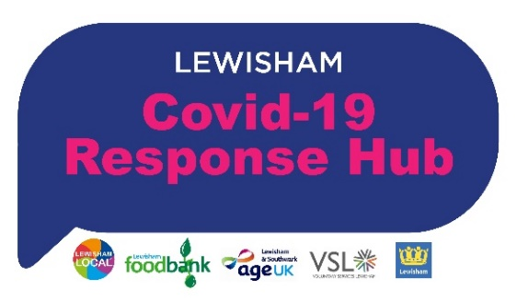
Hello,

As you know, to address the unprecedented public health challenge, Lewisham Local, Voluntary Services Lewisham, Lewisham Food Bank and AGE UK Southwark & Lewisham are working with Lewisham Council to deliver food, befriending and practical support to the most vulnerable in the borough. We are also supported by a wide range of community partners (including Citizens Advice Lewisham, Bellingham Community Project, Phoenix Housing, Lewisham Homes, LEAN Arts etc) while also continuing to support local community groups.

The Lewisham Community has come together in the most wonderful way to support people and this has been crucial in this initial stage of the emergency. It feels like we are now moving to a secondary phase where we need to look at a longer term response to the impact of this crisis – while continuing our current support to individuals - and we would like to link with more local Mutual Aid Groups to understand how we can work better together going forward.
With the rapidly changing situation regarding COVID-19 and the effect on individuals and communities, we thought it would be helpful to point people in the direction of support - the Lewisham Local website hosts a variety of resources, good news stories and various updates both local and national and we also want to know what sort of support would be most helpful to you right now. You can also sign up on the website to our weekly newsletters (as individuals, businesses or local community groups) which is a great way of sharing news, resources, help requests etc.
We would really appreciate your time in completing the questions below:

Area / postcodes your Mutual Aid Group covers?
How many volunteers are involved in your group?

How is your group organised and run?
How many vulnerable individuals you have supported & currently supporting?
What support might Lewisham Local be able to provide you?
Do you support any local food projects? If yes, please name them and tell us how you support them:
Would you find any of the following useful:
- Safeguarding guides, toolkits & policies
- Training for volunteers
- News on funding opportunities
- How to refer people to specialist support
- Be linked up to your local councillors

Do you have any good news stories to share? We would like to put out good news stories of people who have been helped to the wider community to encourage them at this time. Please ensure these are generic and do not include any names or personal details.

Would you like us to share your information on the Lewisham Local website?
Contact: getinvolved@lewishamlocal.com
Thank you.
The Lewisham Covid-19 Response Hub, www.lewishamlocal.com

